Janice Krakowsky
Janice is a yoga teacher for people who want to learn more about yoga and how to adapt it to their needs for a lifelong practice.
Through her calm, present, and nurturing way, she’s here to remind you that you are enough; teaching you how to explore yoga with a curiosity about yourself and inspire you to connect and meet yourself where you are. When she’s not on the mat practicing or teaching yoga, you can find her playing games with her three boys (monopoly and uno are big hits), enjoying a leisurely walk with Cici her dog, or shamelessly binge-watching shows with her husband.
www.JaniceKrakowsky.com

Class Description: Yoga Stretch
Take some time on your mat to connect and explore how your body moves. We will move through poses for strength, balance, and opening up tight spaces in a gentle and easeful way.
Props needed: none, but if you like to practice with a blanket for support or as a cushion or blocks have available, strap optional
Email: Joyfulheartyoga16@gmail.com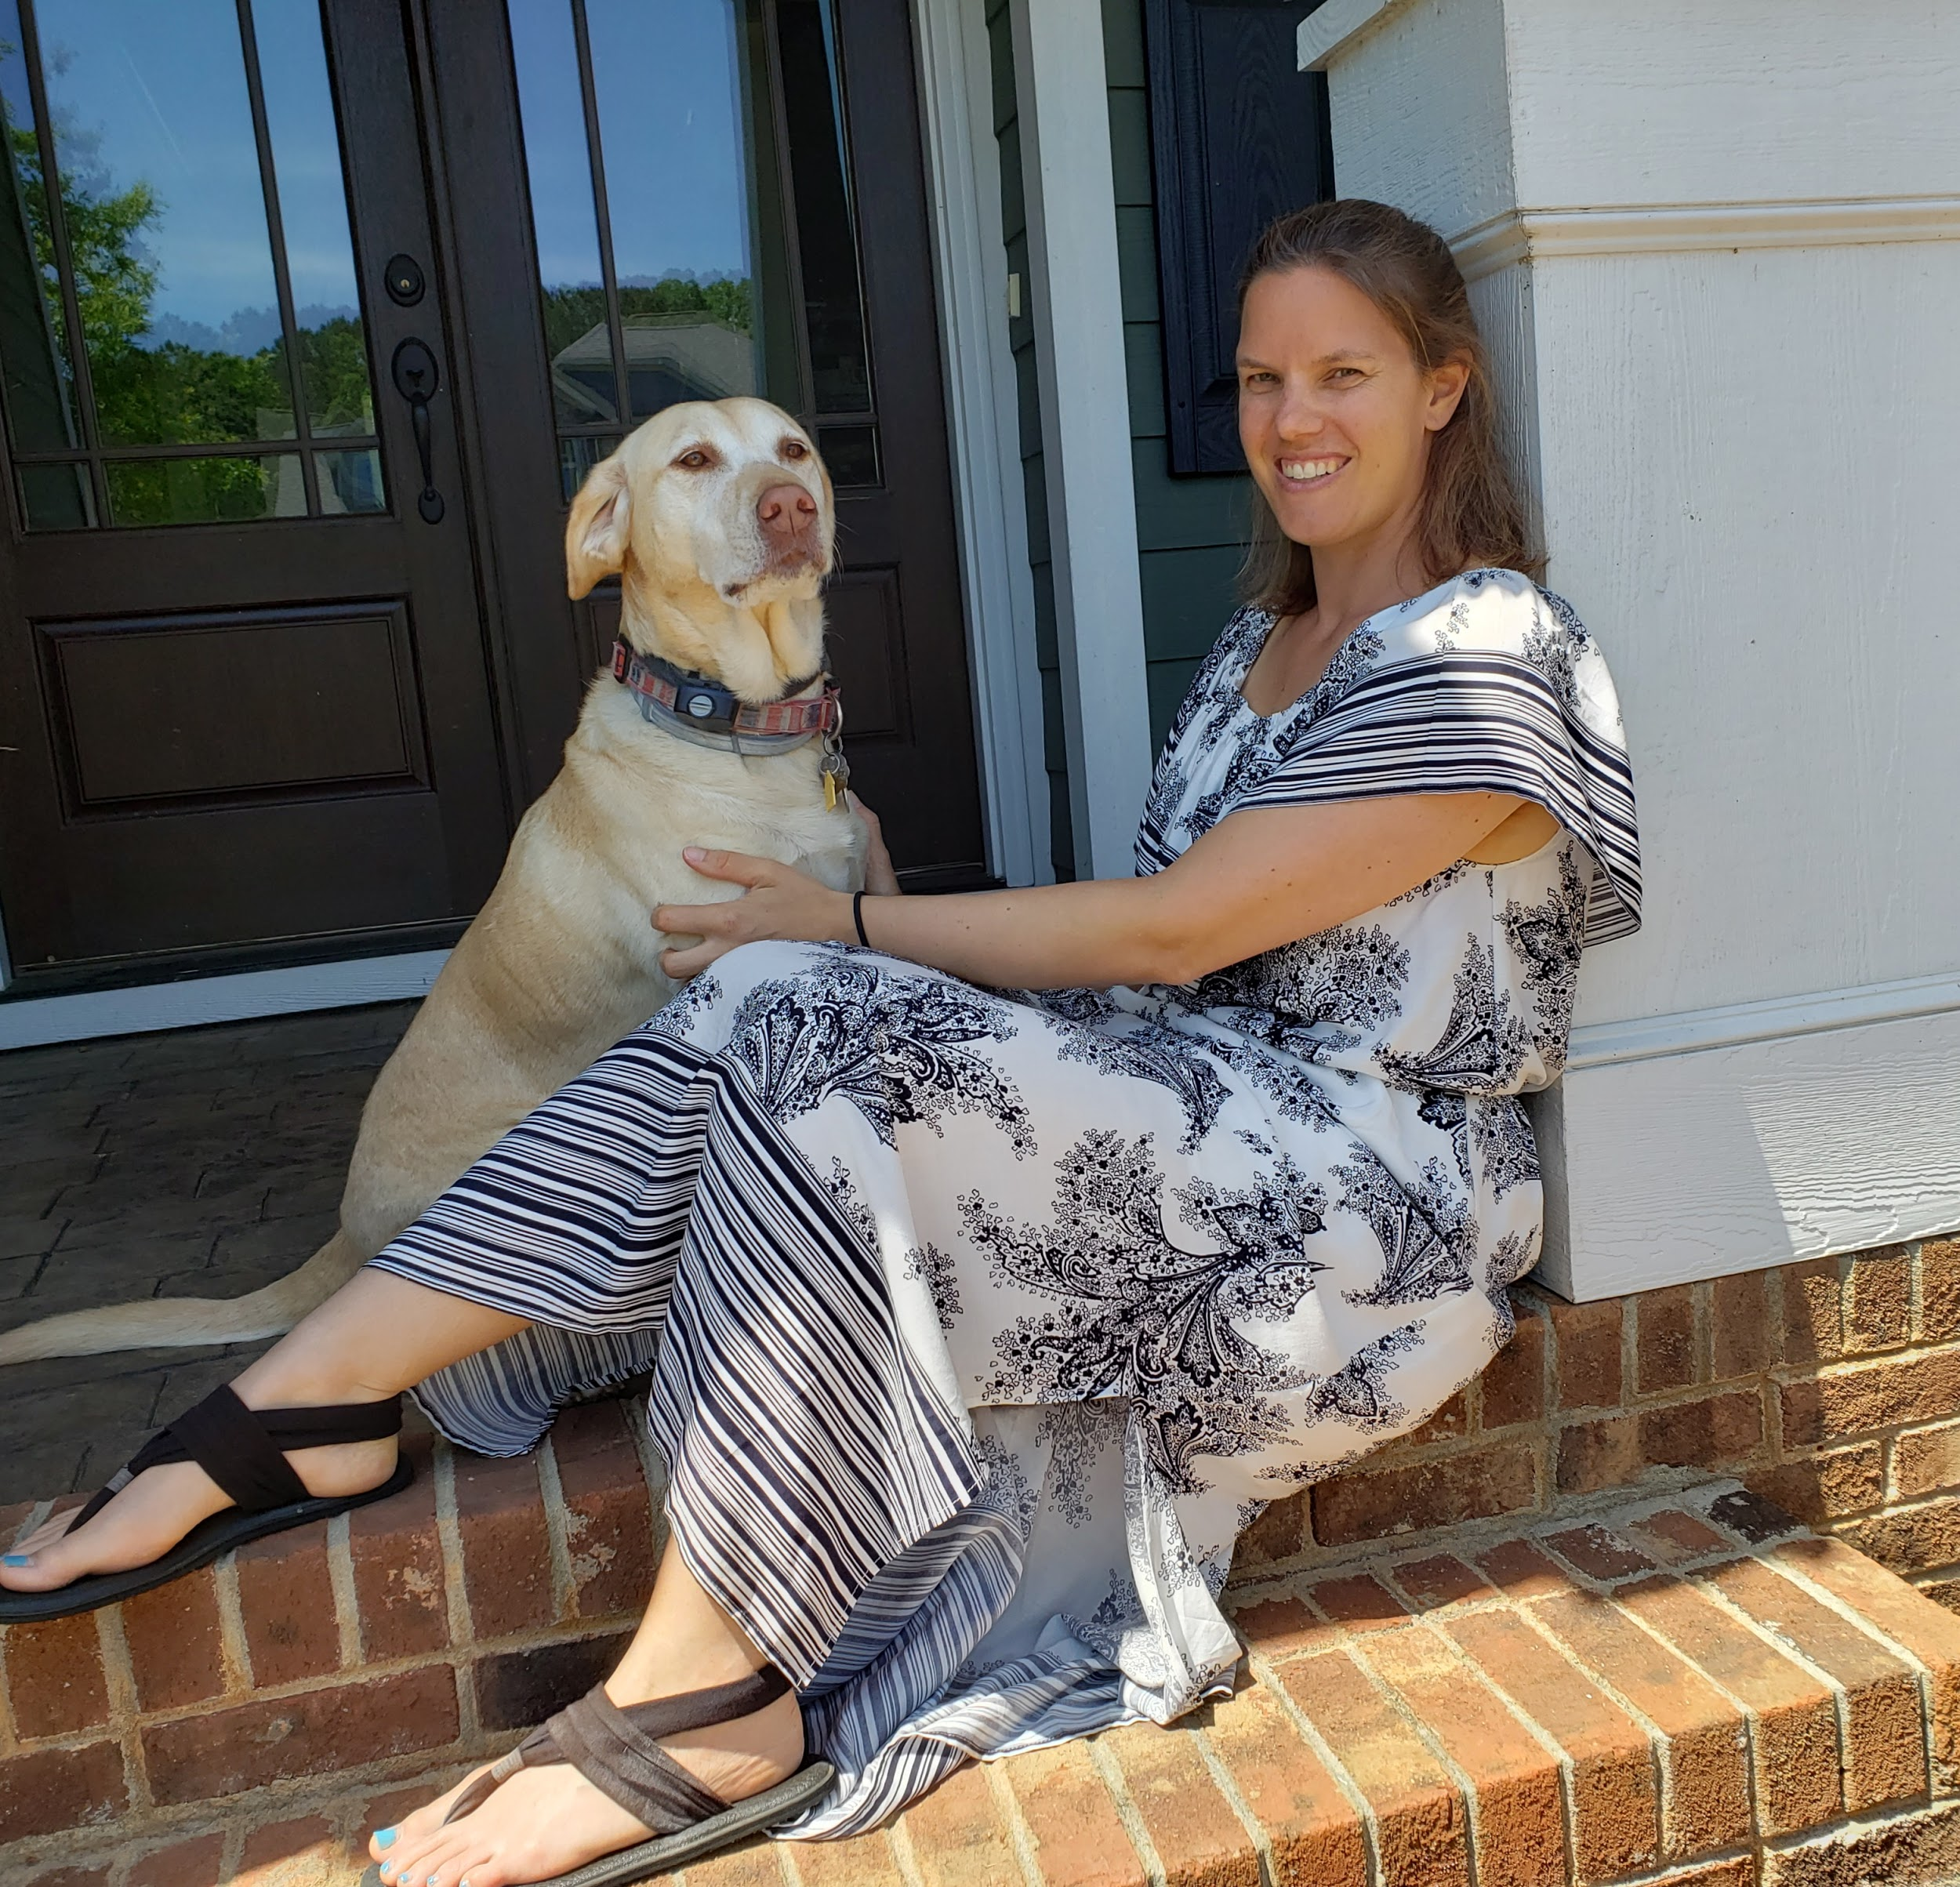

Kristen Rae

Class Description: Stability
STABILITY classes are for anyone wanting to practice static postures with short breaks in between the postures. In this class you will learn how to safely practice a variety of yoga postures building strength and grounding the body + mind.
*much of this class can be taken from a chair
*please have 2 blocks, blanket, bolster or similar available

Margie Satinsky

Publicly Known Name: Margie Satinsky

Social Media: website, www.margiesatinskyyoga.com

Bio:
Margie Satinsky has been teaching yoga since 2004. Given that no two bodies are alike, she’s a strong proponent of blending various yoga traditions so that all students remain comfortable. Each class combines breath work with stretching, proper alignment (Iyengar), slow flow, and holding poses to open connective tissue (Yin). The classes are well-suited for students of all ages, experienced yoga practitioners, and beginners.

Many teachers influenced the development of Margie’s unique practice style. They include Paul Grilley, Sarah Powers, Doug Keller, Gabriel Halperin, Angela Farmer, Tari Prinster (y4c yoga for cancer survivors), Gary Kraftsow, Leslie Kaminoff, Amy Matthews, and North Carolina teachers Tracy Bogart, Rebecca Drake, Ti Harmony, Yvonne Cropp, and Carol Krucoff.

Class Title and Description:
Healing Yoga Unique
Each of us needs healing, be it from injury, disease, stress, grief, or other life experiences. Enjoy a gentle integration of multiple yoga styles, including breath work, stretching, Yin (holding the poses), slow flow, and balance, with special emphasis on correct alignment. No two bodies are the same, and we’ll explore multiple options so that all participants are comfortable. (Suggested for beginner and intermediate yoga levels. Appropriate for very low to average mobility range. Required props: 2 blocks, blanket, strap or necktie, bolster or pillow).

Margie Satinsky

Photo: Attached

Email: margiesatinsky@icloud.com. Website is www.margiesatinskyyoga.com

Phone numbers: (919) 383-5998 home/work; (919) 812-2235 cell/text

Postal zip code: 27705

Websites/marketing outlets: I will share information about the festival with all of my students and at the places where I teach (Millenium Gym and Beth El Synagogue), as well as with other teachers

Poonam Bhasin

1- Publicly Known Name: My name is Poonam Bhasin and I am known across Social Media through my brand name Dhyana-Grha

2- Social media (Facebook, Instagram, LinkedIn, etc.) & website links

https://www.facebook.com/dhyanagrha

https://www.instagram.com/dhyanagrha

https://www.twitter.com/dhyanagrha

www.linkedin.com/in/poonam-bhasin-54695064

www.dhyanagrha.com (this is currently under maintenance but should be up soon)

3- Bio (2 paragraphs)

Passionate about yoga & wellness and a keen believer of the yoga philosophy and practice, I am Poonam, the founder of Dhyana-grha, which, when translated means Meditation House. I am a Certified Meditation teacher & Sound Healing practitioner. I specialize in Sound Baths, Sound Immersion Meditations and Sound Massages. My journey to Dhyana took me to various places, externally and internally. Deciding to look within and reorder my time, my life and live my passion to serve. I quit my high profile fashion/ retail job and decided to continue what I started off in 2004! My calling to Yoga and Meditation. A while later Dhyana- Grha was conceptualized and soon established in Vancouver B.C.
I have completed my Certificate in Yoga Teacher's Training Course from the Academy of Yoga, India in 2004, as well as my refresher 250 hours YTT certification. I am an E-RYT & YACEP with Yoga Alliance and thoroughly enjoy spreading the teachings of Patanjali and actively strive to personally manifest the spiritual quotient.

4- Class title and description (1 paragraph)

Sound Immersion
Sound Immersion, simply put is soaking yourself in the frequencies of sound while integrating that immersion with stillness and silence. With the use of deep resonator bowls that are specially hand crafted in pure bronze; these bowls emit long, sustaining and mild vibrations, that travel deep within your being. At the same time, the beats of the various singing bowls rhythmically create a subtle musical resonance. An immersive experience with sound, the session starts with a brief settling down guided meditation. The next 25 minutes is an experience of pure, rich and energizing sounds created by our hand-crafted singing bowls. You will experience deep sounds which offer you the chance to reach out to them, follow them with your breath, your body and your mind. This session places sound vibrations deep within your energy being. Get set to stage a calming live concert within yourself.

5- Photo (high resolution, if possible) please send as an attachment

Shared 2 options- Please select as suited to your promo style

6- Email that students can reach you at plus links to your website

poonam@dhyanagrha.com
www.dhyanagrha.com

7- Your phone number

+1 506-688-4674 (However, in August I may be operating out of Dubai so my number will be +971-50-189-2267

8- Your postal zip code

V4N 6M8

Yoko Nakano

1- Publicly Known Name:
Yoko Nakano,MD

2- Social media
Facebook:https://www.facebook.com/medcareyoga
Instagram:https://www.instagram.com/medcareyoga/
website:https://medcareyoga.com/en/

3- Bio (2 paragraphs)
Yoko Nakano, MD, RYT

I’m a board-certified anesthesiologist and accessible yoga teacher, living in Tokyo, Japan. I’m a founder of MEDCAREYOGA.
We provide accessible yoga for people who need yoga for various reasons with the co-founder Teruki Nakano, MD, MBA, RYT.
Our mission is to make communities for raising their social capital.

4- Class title and description (1 paragraph):
class title: Accessible yoga-stress releasing

Based on gentle accessible yoga.
For people who feel stress and lose their balance mentally and physically in life with COVID-19.

5- Photo (high resolution, if possible)
please send as an attachment
OK!

6- Email that students can reach you at plus links to your website
medcareyoga@gmail.com

7- Your phone number
+81 80 1420 0303
I do not want to disclose my phone number publicly.
I want you to make sure this information is meant to be only within your organization.

8- Your postal zip code
106-0047
I do not want to disclose my postal zip code publicly.
I want you to make sure this information is meant to be only within your organization.

Liz Oppedijk

1- Publicly Known Name: Liz Oppedijk

2- Social media (Facebook, Instagram, LinkedIn, etc.) & website links 3- Bio (2 paragraphs)

www.accessiblechairyoga.com
www.facebook.com/accessiblechairyoga/
www.instagram.com/accessiblechairyoga/
https://www.linkedin.com/in/liz-oppedijk/

Bio:
Liz came to yoga in her fifties, following serious illness and injury. Through yoga, her recovery became a transformation. But she was left with a question: how to bring the restorative practice of yoga to people for whom the mat is a barrier? She found her answer in Lakshmi Voelker Chair Yoga. Since training with Lakshmi, Liz has taught chair yoga to people with varied abilities, including those with Parkinson’s, MS, stroke, and cancer, as well as those with dementia, learning disabilities and their caregivers. Her commitment to accessible yoga led her to establish Accessible Chair Yoga CIC, a non-profit social enterprise. ACY is dedicated to bringing yoga to everyone, regardless of age, ability, or physical or mental condition, in particular to UK nursing homes, by training others to teach chair yoga and by sponsoring research into yoga’s effectiveness in the social care sector.

4- Class title and description (1 paragraph)

Chair Yoga to Boost Energy & Build Confidence

Chair yoga is often perceived as yoga for those who want a quiet, meditative practice, or only for those who have physical limitations. And, of course, it’s brilliant for these practices! You can also have a real workout on a chair, even if there are physical challenges. This class will incorporate all yoga’s wonderful elements – intentional breathing, purposeful movement, and mindful meditation – to bring energy and confidence to body and mind. Join us for a workout and a “work in” – fully accessible to all!

5- Photo (high resolution, if possible) please send as an attachment

Attached

6- Email that students can reach you at plus links to your website

info@accessiblechairyoga.com
www.accessiblechairyoga.com

7- Your phone number

+44 (0)7910 964668

8- Your postal zip code
AL1 4EP, UK
1- Publicly Known Name: Claire Cunneen

2- Social media:
Www.facebook.com/lvcyau
Www.instagram.com/lvcyau
https://www.linkedin.com/in/claire-cunneen-lvchairyoga-australia/
website: Www.getfitwhereyousit.com.au

3- Bio

Claire began her career as a group fitness instructor in the late 90s. She holds a Degree in Sport & Exercise Science, and is a Yoga Therapist, along with many other qualifications. Drawing from both personal and professional experiences throughout this time, she has developed a passion for helping others to live not only healthier, but happier lives. She is dedicated to creating sessions that are welcoming and inclusive for everyone.

Her teaching is beneficial for the physical body, soothing for the mind, yet also fun and uplifting. Her goal is to positively impact anyone that she encounters - inspiring people to feel connected, happier, and live life to the fullest, no matter who they are, what body they are in, or what stage of life they are at. As an Accessible Yoga Teacher and owner of LV Chair Yoga Australia she is striving to make Yoga accessible and available to everyBODY!

4- Class
LV Chair Yoga Class

This Chair Yoga class is perfect for everyBODY but especially for those who want to participate in yoga but have challenges getting down to a yoga mat on the floor. The class is taught in a way that is supportive and inclusive for all members of the community. All of the yoga poses are adapted to the chair, with multiple options offered so that everybody can participate at the same time, regardless of age, level of experience or ability. If you are in a wheelchair - you can join our class. The student can take an approach that may be gentle and mindful, or more dynamic and challenging depending on their own personal needs. Get fit where you sit on any chair, anywhere!

5-
Attached
Photo (high resolution, if possible

6- Email that students can reach you at plus links to your website
Claire@getfitwhereyousit.com www.getfitwhereyousit.com.au

7- Your Phone
+61 421077355

8- Your
postal zip code: 2042

9- any community websites or marketing outlets in your region -optional, and
helpful
I can post marketing materials in the facebook groups I’m in, I’ll also send to my newsletter and Lakshmi’s newsletter - I will let you know if I think of other ways to spread the word too!

Amma Fandiño

1- Publicly Known Name: (ex my name is Kristen Lacy but people know me as Kristen Rae)
Amma Fandiño

2- Social media (Facebook, Instagram, LinkedIn, etc.) & website links

Facebook:
Accessible Yoga- Español
https://www.facebook.com/groups/271908559924958

Website:
https://maria-amma-fandino.offeringtree.com/

3- Bio (2 paragraphs)

Amma Fandiño, RYT500, has been a devoted yogini for over 28 years and a passionate biologist for 27 years. She holds a master degree in environmental sciences from Yale University and is a certified Integral Yoga and Accessible Yoga teacher. She is also trained in Therapeutic Yoga, Yoga for Arthritis, Yoga of Recovery, Lifeforce Yoga, Prison Yoga, and Mindfulness. Amma's passion is to share yoga with communities with challenges and conditions of vulnerability on a physical, mental, and emotional level. Amma has been dedicated to teaching cancer patients and their caregivers. Amma´s inspiration is bestowing support to patients in order to improve their quality of life as well as their ability to cope with the difficult circumstances associated with the disease. Another facet of Amma´s vocation is teaching yoga to people with anxiety, depression, and addictions. Currently, she teaches in two prisons in Bogota. She dedicates her efforts to provide a space that promotes empowerment, rehabilitation, and healing of those deprived of liberty, as well as supporting their addiction recovery processes. Amma is contributing to the Accessible Yoga Program since 2015 and is a regional representative of the AY group in Spanish. As a Yoga Accessible Trainer, she feels honored and fortunate to support the training of yoga teachers in the Spanish-speaking community. She lives in Colombia with her husband and two kids and loves to spend her free time in contact with nature.

4- Class title and description (1 paragraph)

Accessible Yoga
Accessible Yoga is an inclusive gentle class designed for anyone focusing on healing and stress reduction, regardless his/her condition or level of physical ability. This class offers a unique fluid combination of asanas (seated and standing), breathing practices and relaxation techniques that allow you to feel both relaxed and energized at the same time. The emphasis of the class encourages an inward connection and is an opportunity to cultivate ease in the body and quiet in the mind, that will give you a greater sense of wellbeing. Recommended props: a mat, a sturdy, stable chair, a blanket and a pillow.

5- Photo (high resolution, if possible) please send as an attachment

6- Email that students can reach you at plus links to your website

amma@accessibleyoga.org

7- Your phone number

+57 315 781 6766

8- Your postal zip code

110231 (Bogota- Colombia)

9- any community websites or marketing outlets in your region -optional, and helpful
Accessible Yoga- Español
https://www.facebook.com/groups/271908559924958

1- Publicly Known Name: Flowithme is the company name, I am known as Sara but i go under my brand Flowithme
2- Social media (Facebook, Instagram, LinkedIn, etc.) & website links :

www.flowithme.com
Facebook - https://m.facebook.com/flowithmeIE/
Instagram - https://www.instagram.com/_flowithme_/
YouTube - https://m.youtube.com/channel/UCRMBg8YInoLbk1mshrHCcKQ

3- Bio (2 paragraphs) -
Sara De Miguel Hernandez from Flowithme lives in Cork, Ireland where she helps people to navigate their wellness journeys.
Sara’s technique incorporates the practice of chair yoga, life coaching and cooking with Thermomix, helping her clients to reflect, rebalance and refocus in any area of their life.
Sara works both with individuals online on a one-to-one basis and with larger corporate groups in English and Spanish.

4- Class title and description (1 paragraph) - let's discuss what type and i will do a write up for you.
5- Photo (high resolution, if possible) please send as an attachment - attached.
6- Email that students can reach you at plus links to your website :sara@flowithme.com
7- Your phone number +353 851 387 984
8- Your postal zip code: Ireland
9- any community websites or marketing outlets in your region -optional, and helpful - a couple of Cork and Irish facebook groups.

Ingrid Saddler-Walker

Name: Ingrid Saddler-Walker (known as Ms. Ingrid)
Facebook: https://www.facebook.com/WythaBalanceYoga
Instagram: wythabalanceyoga
Website: www.wythabalance.com
Bio:
Ingrid began her yoga journey in 2009 with the intention of teaching adults and children. She is the owner of Wytha Balance Yoga – Counseling LLC. Ingrid is a Kundalini trained E-RYT/200 hours Yoga Instructor with a 95-hour specialty certification in children’s yoga. She is also RYT/500 Ashtanga Yoga Instructor.
Ingrid is certified as a Reiki Master Level Practitioner.

Her goal is to teach others and allow them to become present in the moment as they develop a greater awareness of themselves. She is a Kundalini certified Yoga Instructor with a certification in children’s yoga and mindfulness. Ingrid’s training consist of Kundalini Adult/Family Yoga, Radiant Child Levels I, II and III, YoKid Stretch Your Limits (specializing in working with children in grades K-12), Yoga 4 Classrooms, Yoga and Mindfulness for Children, Yoga for Teens, Mindful Schools Fundamentals, Mindful Schools K-12, Mindfulness for School-Age Children. In March 2019 she completed an Advanced Yoga Teacher Training with Mind Body Centering Yoga. She is also a NC Licensed School Counselor with 20 years of experience in Durham Public Schools.

Class Title: Yoga Kids have Yoga Fun– Empowering, Uplifting and Relaxing!
Description: This yoga experience empowers, uplifts and relaxes you as you experience yoga and mindfulness in a safe space. Enjoy music, games and fun! This experience encourages positive thinking, problem solving skills and enhances self-esteem. Engage in your yoga experience to express your creativity on the mat.

Photo: Attached

Email: info@wythabalance.com

Phone: 919-423-8844

Postal Code: 27713

